Wireframe Documentation

Prediction of LC50 value using QSAR Models

# Homepage

The home page consists of six input fields, which are 6 attributes (molecular descriptors) needed for the prediction of quantitative response LC50 [-LOG(mol/L)]

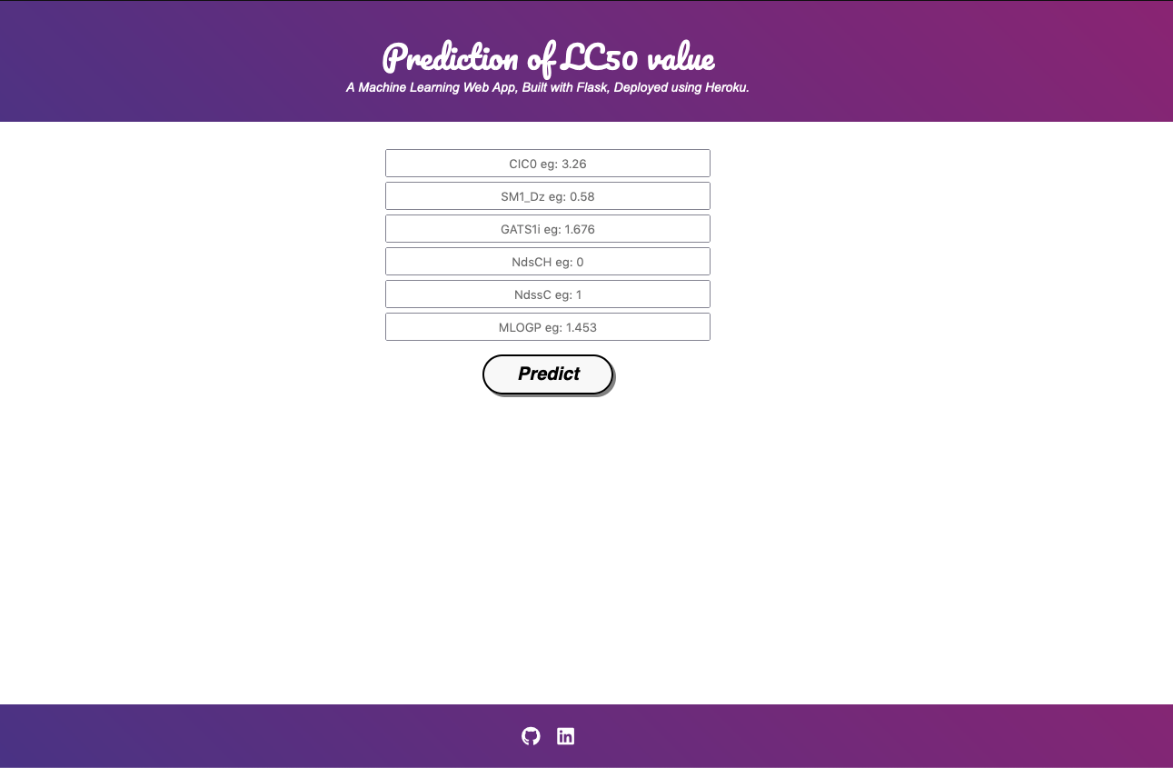

Upon successful completion of filling the attributes and clicking on Predict button, the result page will show the predicted output as follows

